**Week 4 blog post**

**Topic –**

Week 4 – ViewController

Music Player app

**Snapshots of the final product –**

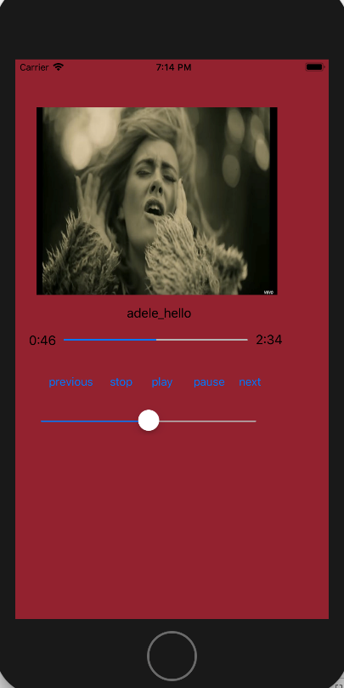

Fig 22: The simulator view playing the song ‘hello’ by adele.

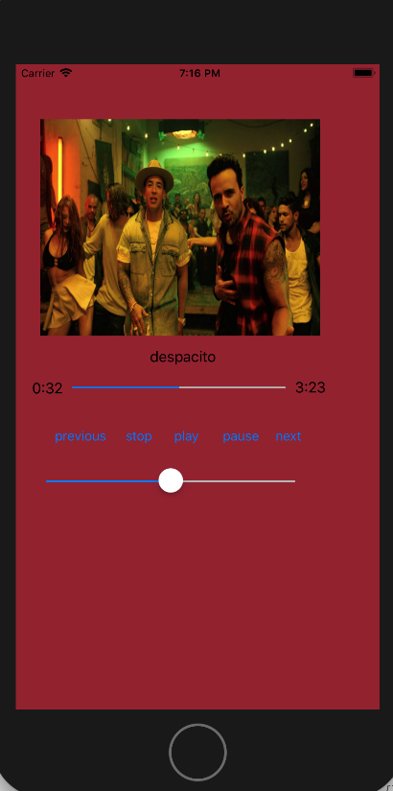

Fig 23: The simulator view playing the song ‘despacito’.

**How I implemented –**

For making this application we were already provided the three songs and a file which had two class:Playlist and MusicPlayer as shown below.

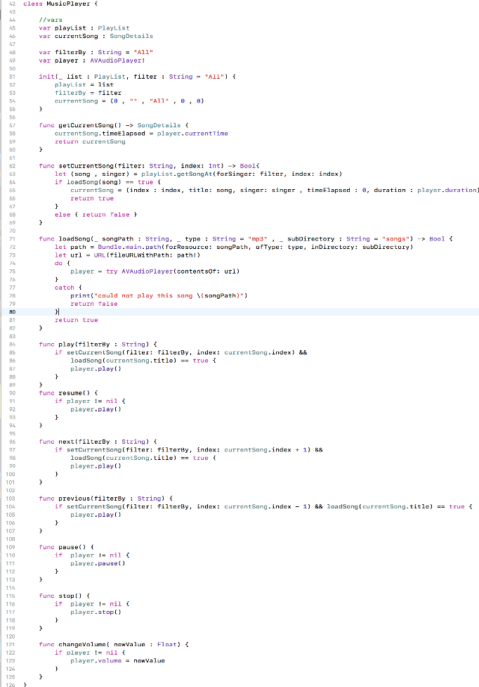

Fig 24: Snapshot depicting the MusicPlayer class

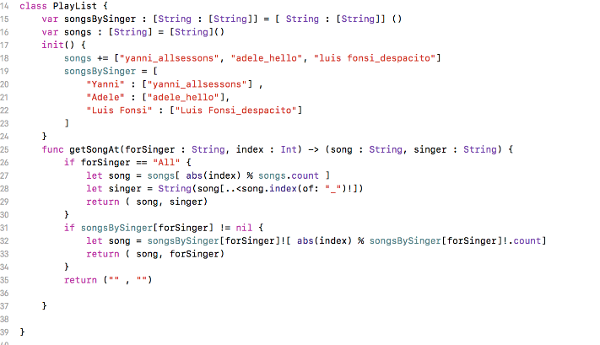

Fig 25: Snapshot depicting PlayList class

The PlayList class basically stores the playlist of the songs and returns the song and the singer.

And the MusicPlayer class contains the all the functions of the music player like play, pause, etc which gets called from the main viewController.

When I created the main storyboard I added all the music function buttons, the slider bar and the progress bar. The slider bar for controlling volume and the progress bar for checking the duration of the song, and also added a image view and a label for the song that is being played.

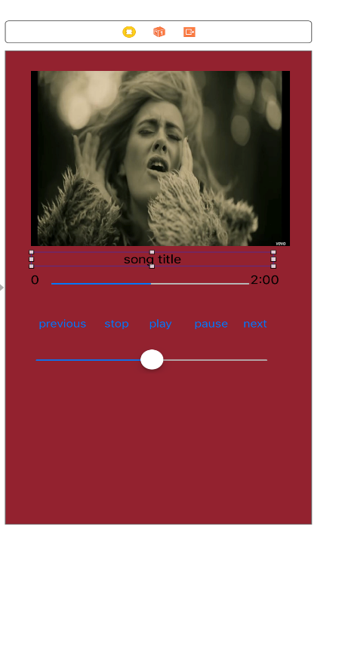

Fig 26: Snapshot of the main storyboard.

Songs and images were added in the assets file. Then I connected the music player buttons and labels to the view controller also each button function had a action associated with it like play, pause, next and etc, The functions are shown below.

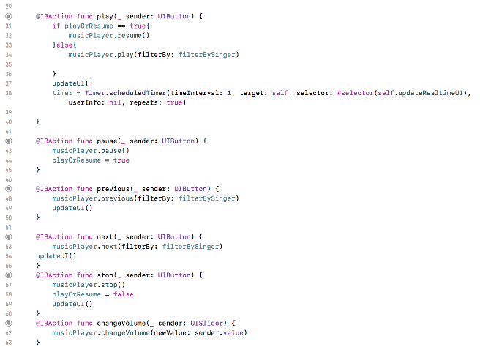

Fig 27: Code snippets of the various functions of the music player app

The updateRealTimeUI() function is used for showing the time in the progress bar for the elapsed time of the song and time remaining for finishing the song. And the updateUI() function is used for updating the interface of the images and label of the song being played. The snippet of the two functions are shown below.

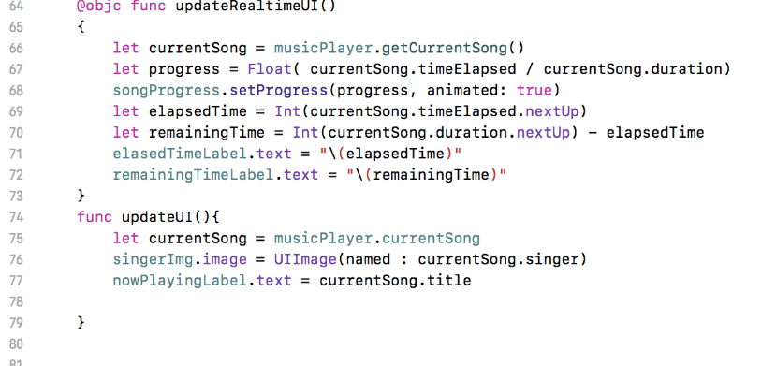

Fig 28: The snapshot of updateRealtimeUI() and Updateui() functions

**Reflection –**

This app helped me understand a lot about view controllers. It helped me develop enough knowledge to finish the assignment 1. With so many classes involved in this app made it a little difficult to finish the application in two hours as I got lot of errors in almost every step. I got to learn a lot about the various functions that I could use while building my tic tac toe app. From this week I feel that the subject has become way more challenging and I would need to do some more research to finish the assignment application. From adding files to the project to getting to work with new features like slider bars and progress bars, I have certainly learned a lot in this week.